SIMPLE MACHINES: Levers
Name: | Date: | Teacher:

A simple machine can make a task easier in three ways:

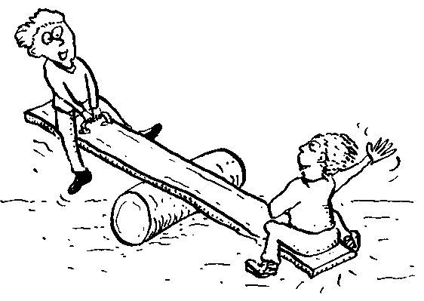

A lever is a bar such as stick or metal rod and a fulcrum which it pivots on. Most levers decrease the effort needed to move a load.

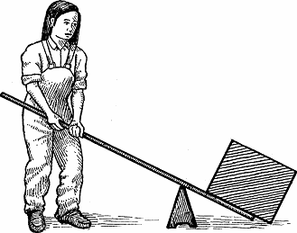

What do you know about levers?
Statement | True/False/Not sure
1. The point that a lever turns about is called the fulcrum.
2. The fulcrum is represented in drawings as a square.
3. A force applied to a lever is called a downward effort.
4. The object that is being shifted is called the load.
5. The direction in which the effort or load on a lever is acting is shown in arrows
6. The distance between the fulcrum and the load is called the load arm.
7. The force advantage would apply when a large effort moves a small load.
8. Levers can give a force advantage or a distance advantage
ACTIVITIES
Equipment :
lever  spring balance 2.5N, 5N, 50N | fulcrum | load (slotted masses)  paperclip

Type One Lever: a type one lever has the fulcrum positioned between the effort and the load.
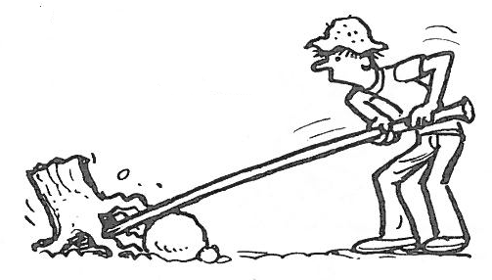

L= LOAD F = FULCRUM E= EFFORT
Part 1 Method:
- Set up the lever so that the fulcrum is 20cm from one end.
- Hang a 300g load from the end closest to the fulcrum [0cm].
- Using a paperclip hang the 2.5N spring balance to the 100cm mark and pull downwards on the hooked end until the lever is level. Record the amount of effort (force) it takes to hold the lever horizontally.
- Repeat for the next 2 loads.
Results:
LOAD (g) | EFFORT (N)
300
400
500

Discussion:
How did the effort change with the load?

Part 2 Method:
- Set up the lever so that the fulcrum is 60cm from one end.
- Hang a 300g load from the end closest to the fulcrum [0cm].
- Using a paperclip hook the 5N spring balance to the 100cm mark and pull downwards on the hooked end until the lever is level. Record the amount of effort (force) it takes to hold the lever horizontally.
- Repeat, changing the fulcrum each time but keeping the load the same.
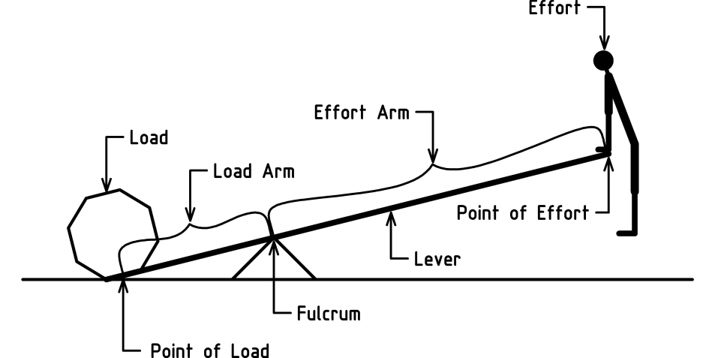

Results:
Fulcrum position (cm) | Effort arm length (cm) | Effort (N)
60
70
80
90

Discussion:
What happens to the effort required as the load arm increases in size?

Type Two Lever: a type two lever has the load positioned between the effort and the fulcrum.
L= LOAD F = FULCRUM E= EFFORT

Part 3 Method:
- Set up the lever with the fulcrum at 0cm.
- Hang a 300g load at 50cm.
- Using a paperclip hang the 2.5N spring balance at the 100cm mark and lift upwards using the hooked end.
- Record the effort taken to lift the lever.
- Repeat, increasing the load each time.
Results:
Load (N) | Effort (N)
300
400
500

Discussion:
How did the effort change with the load?

Is there a force advantage when using a type two lever?

Type Three Lever: a type three lever has the effort between the load and fulcrum position.

Part 4 Method:
- Set up the lever with the fulcrum at 50cm.
- Hang 300g on the 100cm mark.
- Using a paperclip hang the 50N spring balance at the 75cm mark and LIFT upwards using the hooked end
- Record the effort needed to hold the lever horizontal.
- Repeat, increasing the load each time.
Results:
Load (g) | Effort (N)
300
400
500

Discussion:
What happened to the effort as the load increased?

Is there a force advantage using a type three lever? Explain.

The lever as a simple machine
The pivot point (a fixed point) is called the fulcrum, this is shown as a triangle. When you apply a force to the lever this is called the effort and an arrow shows if you are pushing up or down. The object you are trying to move is called the load, an arrow shows where it is acting.
The load arm is the distance from the load to the fulcrum.
The effort arm is the distance from the effort to the fulcrum.
A lever can be used to gain a force advantage OR a distance advantage.
A force advantage is gained when the effort force used is less than the load force that is moved.
A distance advantage is gained when the effort force is moved through a shorter distance than the load force.
Classify each of the following as 1st, 2nd or 3rd type levers.

Identify the type of lever they are (1st, 2nd or 3rd). Locate and label the levers with effort, load and fulcrum for each example.



